 | To: |  | Fax:
 | From: | Nordic Bulk AS | Date:
 | Subject: |  | Order by:
 | Please return confirmation, incl. article number, on fax: +47 51 97 41 61

Forespørsel Styrerull

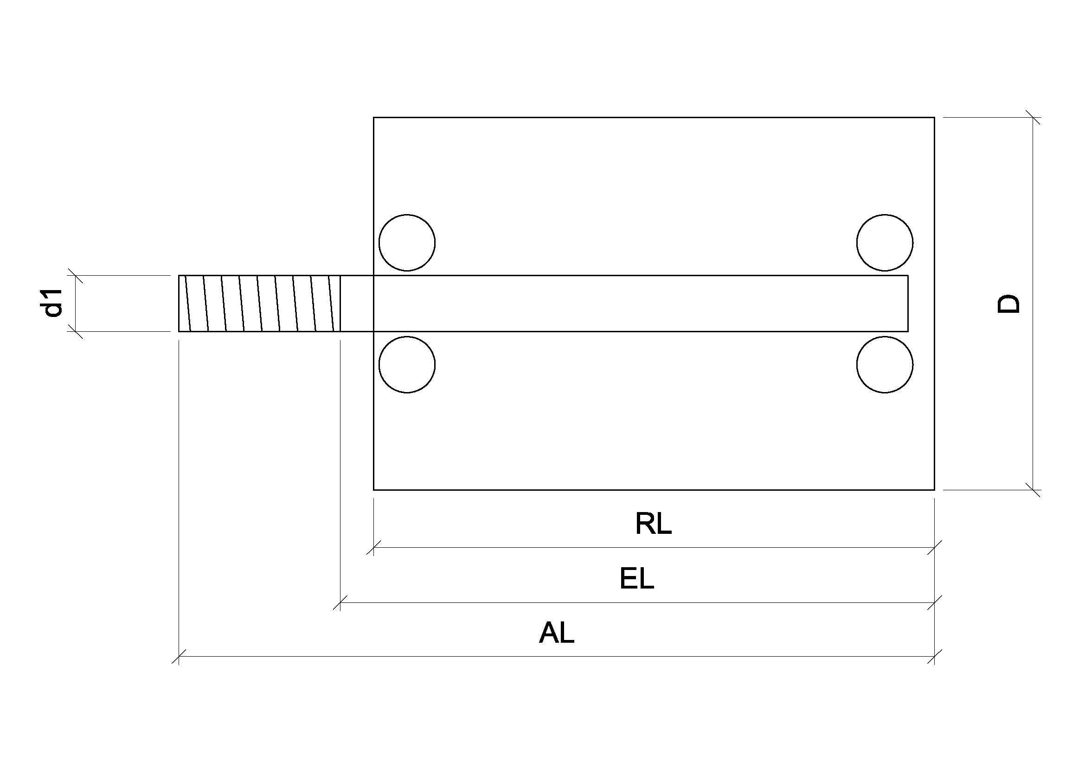

Quant: | D | d1 | M | RL | NV | EL | AL | Price | Article number

Comments:

